Study of the avian soundscape using acoustic indices linked to islands variables and native - exotic bird community.

  - Introduction
- Bird songs

Mechanisms of song
Evolution of bird song

Advantage of this type of communication
Vocal communication plays a major role for individual birds’ fitness. A large variety of signals are used at interspecific and intraspecific levels, they are keys for mate choice (Richardson & Lengagne, 2010), rival evaluation (Searcy & Beecher, 2009), danger signalisation ( ) or individual recognition (Chaine, Shizuka, Block, Zhang, & Lyon, 2018).
These signals are keys for evolution and differentiation process acoustic interference can lead to the apparition of differentiated signals between interfering species; such a pattern was observed on a small Galapagos island after a new finch species joined the two‐species community (Grant & Grant, 2010).
Description of the main type of songs produced, and their complexity.
Bird songs are a complexed processus that can be categorised between calls, songs and specific interaction vocalisations. Large panel of vocalisation can be described for a species, accent are also present at the intraspecific levels. They serve for the description of very morphologically similar species.
- Island ecosystems & French Polynesia

Colonization and age of this islands, natural vegetation type
Island ecosystems are biogeography defined by two main traits that are isolation and small area, causing together species‐poor insular communities (MacArthur & Wilson, 1967). This native community have been shaken with the first human arrival. Importing the exotic species, such as Gallus gallus or Rattus polynisiensis?
- Island ecosystems, theatre of exotic species introductions (impact of introduction)
European colonisation imported larger patch of exotic species that are not that old and turned these insular ecosystems into highly introduced species ecosystems. The reasons are numerous, from the anthropic sides with human colonisation, agricultural development and large transport traffic. And environmental sides, with evolutive-loss of competitive characteristics, small areas.
These places are so victim of ecological changes due to this ecological invasion and has usually high impact on the native community. This is currently true, and biological invasion will continue to impact island ecosystems, supported by other massive threats such as climate change or anthropization process (Lenzner et al., 2020).

Bird introduced to Tahiti :
In this misfortune, these ecosystems, as French Polynesia in our case, are so known to offer opportunity for the study of invasion processus and their impacts, that on different levels. Indeed, they are good environments to work on invasion ecology, and study invaded ecosystems, with simple avian community supporting high proportion of exotic species.
Explain the type of birds introduced:

- Explication of soundscape
e soundscape encompasses all biological, geophysical, and anthropogenic sounds in an environment and serves as an important communication medium for biota.

Type of soundscape studied the most, in what quantity and where in this review: (Turlington et al., 2024) Four main habitat are mostly studied for their soundscapes, with variate mean number of hours and sites recorded. Each main habitat type as several sub habitat for where studies are conducted. At the time of this study, the method to work on the soundscape is mostly using acoustic indices (74.3 %), followed by manual methods (23.8 %) and call recognisers (14.9 %). Across publications using acoustic indices, 61 unique indices were used in totals: (Turlington et al., 2024).
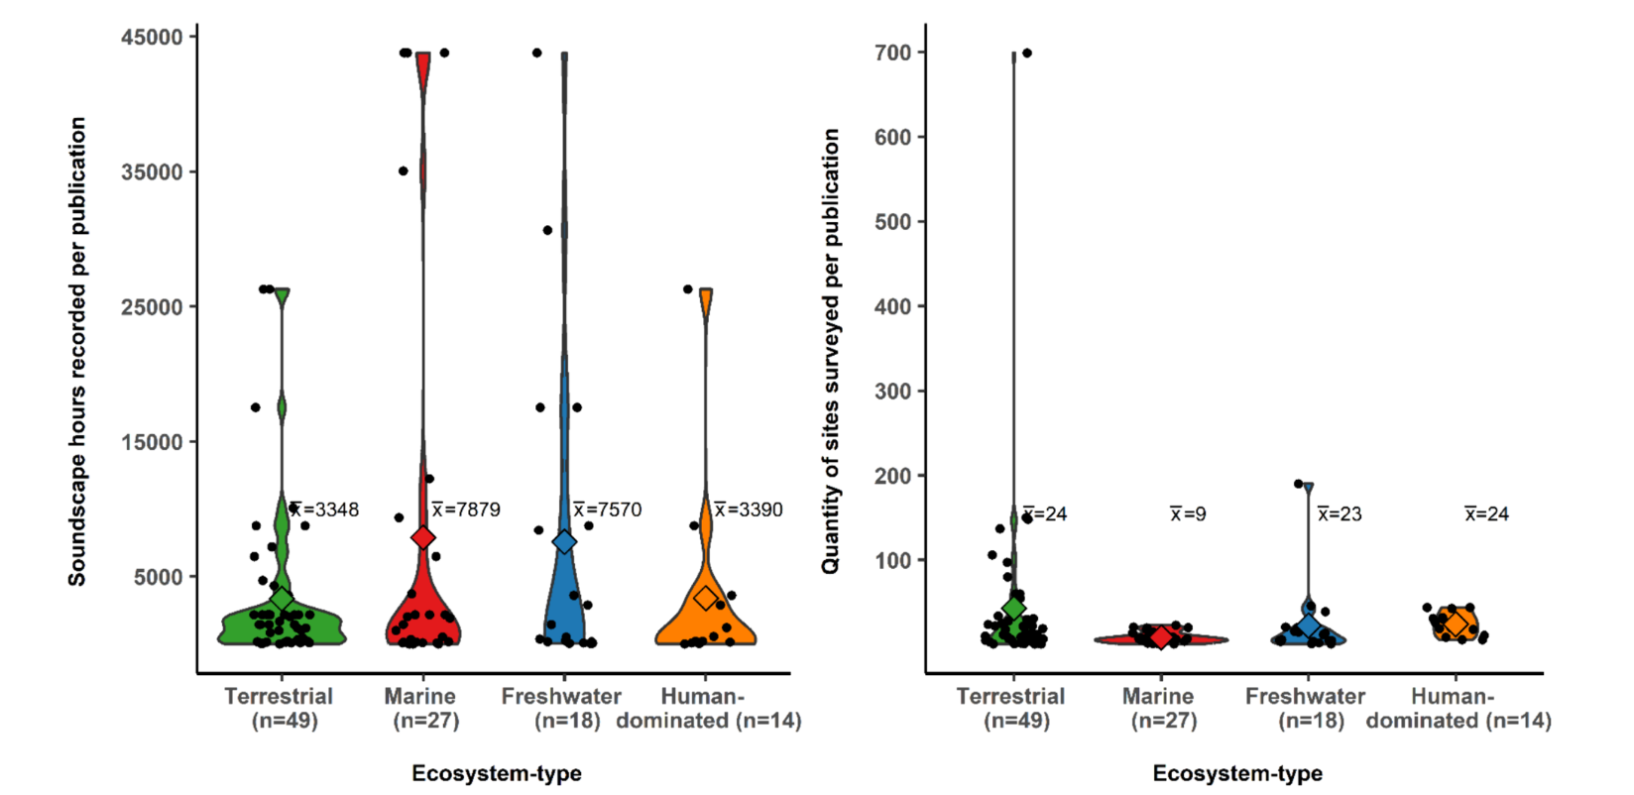

Explication Niche partitionning
- Exotic bird species impact and soundscape impact
As highlighted by several studies, invasion and urbanisation gradient can play a role in shaping avian community composition (Rogers et al., 2021). So, the presence of this vocalising exotic species may also modify the acoustic community and their pattern. Soundscape’s modification may impact the communication between native species, and so change their occupancy, distribution and behaviour.
Species interference is expected to affect acoustic signals more strongly than, for example, visual signals, since acoustic.
Bird invasion process modifies the soundscape. First new avian species, bring vocalising signals in the invaded soundscapes, and so acoustic interferences. This new species interference may affect acoustic signals communication, since they signals transmit over longer distances and thus can easily mask each other (Wilkins, Seddon, & Safran, 2013). Plus, higher number of vocalizing bird species has been shown to correlate with the detection of more background noise. This noise can be described as acoustic interference, and so potential interspecific competition for acoustic space. (Alois Robert soundscape.)
Current avian composition in French Polynesia is quite unique compared to continental community. Biological introduction shapes their composition, and fewer native bird species is found on Tahiti rather than exotics one. That is for richness, but also for abondance.
Table of species introduction Tahiti:

For instance, Common myna, which have been associated with the decline of native bird community (Grarock et al., 2012). This highly vocalising species may impact the avian soundscape community. These changes could be highlighted using acoustic indices.

- The use of ARU and acoustic indices in ecology:
The uses of ARU and PAM methods on islands is still a field in development (), they are used to run acoustics indices analysis on vocalising species, to acknowledge activity, occupancy and densities (Marques et al., 2013). They have been used to work on a large variety of taxa, with a wide spectrum of assessment methods and goals. They also have been used to work on avian community in an invaded ecosystem (Song et al, 2025).

Passive acoustic monitoring is used to quantify rapidly and with less tool’s biodiversity. These are non-invasive, autonomous and usually omni-directional (sampling a three-dimensional sphere around the sensor). The usual steps for these kinds of studies are schematising hereafter. (Gibb et al., 2019). Will be used in our case as indicator of the bird community activity.

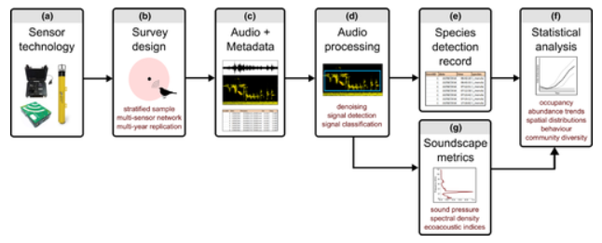
PAM is still limited in its range and can only detected vocalising species, in the right place and time (depends of the designed program of the ARU’s.
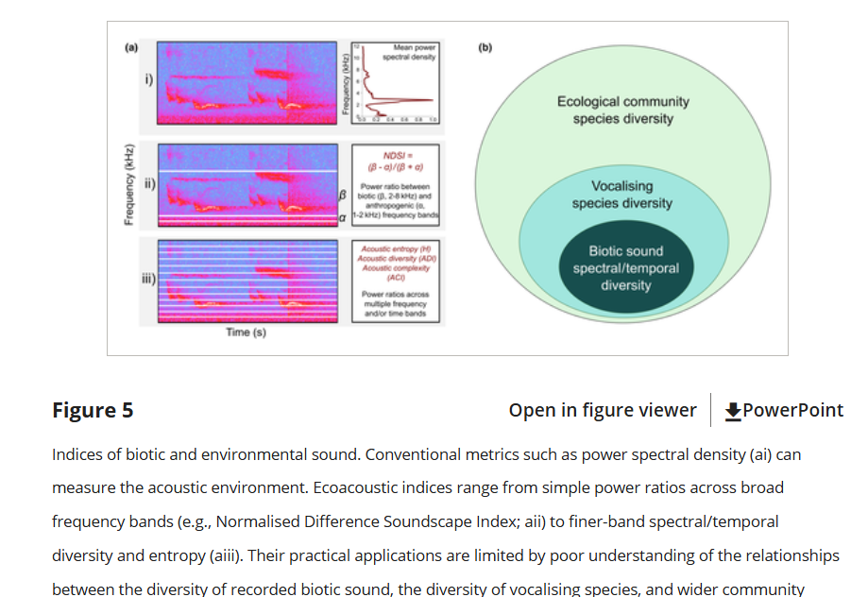
(Gibb et al., 2019)
- Acoustic indices variability in studies
Acoustic indices are efficient metrics that extract and condense acoustic information into single integers which are used to assess the acoustic component of ecological communities (Turlington et al., 2024).
Talk about frequency, fourrier, time analysed, period, type of indices.
Although acoustic indices show great promise for standardizing the analysis of acoustic surveys, the complexity of acoustical conditions necessitates a careful examination of the relationship between an index and the underlying process of interest (e.g., Gasc et al. 2013; Fuller et al. 2015). Zotero de (Buxton et al., 2018)
However, many indices are highly sensitive to site-specific and temporal differences in vocalising animal community composition and nontarget sound levels (e.g., weather, anthropogenic sound, other vocalising species) (Bradfer Lawrence et al., 2025; Staaterman et al., 2017). It is therefore difficult to directly compare acoustic index values between sites and surveys, which limits the reliability of indices in PAM studies that span multiple localities, dates and habitat types. (Gibb et al., 2019).
Acoustic indices results can be highly variables, site and conditions dependant, environmental conditions etc.. The recent hype around this domain also offers a large quantity of indices and can be hard to know which cluster of indices are adapted for our study cases, goals, environment. In order to acknowledge potential indices for longterm monitoring of avian diversity.
(Hutschenreiter et al., 2025) Ici, bon exemple de ca dépend ce qui est mieux dans les indices quoi, notamment en PCA et unique indice. Peut comparer avec Bradfer Lawrence notamment.
Vriability in the relationship fin with environmental variables.
For example, Eldridge et al. (2018) found relationships between bird species richness and acoustic indices were stronger in temperate regions compared to tropical regions, suggesting that the presence of multiple vocalising species interferes with our ability to identify correlations between soundscapes and environmental parameters (such as bird species richness) in tropical regions (Eldridge et al., 2018). Further, Chen et al. (2021) found that elevation strongly predicts acoustic diversity (Chen et al., 2021), largely supporting the literature which indicates that higher elevations exhibit lower species richness (Peters et al., 2016),

However, the lack of standardised methodology in ecoacoustics (Gibb et al., 2019; Vella et al., 2022) often hinders the consistency and transferability of research findings across studies. While the link between sound and the emitter is undeniable, a gap exists in our understanding of how the soundscape reflects the broader ecological context.
Plus, different ecosystems hold distinct biotic and abiotic properties (Gibb et al., 2019) and will likely host unique soniferous biota and physical structures that impact sound (Gaudon et al., 2022).
Goal of this study:
Aim :
This study aims to discriminate acoustic activity pattern from avian communities using basic acoustic indices and considering a panel of adequate biotic and environmental variables.
It is conducted in Tahiti to assess acoustic dynamic pattern from the most avian invaded islands of French Polynesia, and spot acoustic indices that reflects with the steps of invasion process and environmental variables. Indeed, preliminary work will be conducted only on Tahiti, to comprehend the fluctuation of indices within an island where a good quantity of data is available. First goals and hypothesis are so made for Tahiti hereafter.
Goals
1. Work on assessing the avian community composition based on the point counts.
2. Characterise on a large spectrum the avian acoustic dynamism (complexity, diversity, periodicity) throughout acoustic index linked with environmental anthropic/biotic variables
3. Examine several acoustic indices to emphasise differences and similarity within the environment and found appropriate acoustic indices that correlate with some pattern of bird community in Tahiti.
Questions:
1. Which factor can influence avian richness and native/exotic community composition in throughout Tahiti?
2.a Could the relationship between soundscape and specific variables, temporal pattern or avian composition be outlined within acoustic indices.
2.b Does invasiveness indicator variables shapes the avian acoustic activity pattern highlighted by acoustic indices in Tahiti?
3.a Which group or single acoustic indices are well fitted to characterise or predict native and exotic bird community?
3.b Are principal component analysis adapted tools for robust acoustic pattern characterization?
Hypothesis:
- Avian community composition is partially dependent on gradients such as urbanisation or altitudes. That where adequate resource availability for native or exotic birds, is fluctuating with resource abondance, biotic competition and resistance with environmental factors.

- First, we assume that species richness and community can be differentiated throughout acoustic indices fluctuation. Index will calculate scores from complexed, high activity soundscapes in urbanised sites and from quieter, degraded native acoustic habitat. Second, abiotic variable may create differences within indices, due to their calculation methods, and so their sensitivity to certain factor. Some variables are important for affecting acoustic index calculation
Third, soundscape may reflect a temporal pattern variation amongst sites, shows with acousitc indices calculations.

Expectation for exotic species impact are complex to highlight intra-island. Evidence of modification of soundscape will require sufficient data availability in recording and point count community assessment.

- Some acoustic indices sensibility will perform better in response to fluctuations in avian richness or composition. The use of a PCA, considering a good variability index, could show a more global and stabilise characterisation of biotic factors.

Here, we put a foot in contributing to acknowledge if monitoring biodiversity through acoustic indices could be useful in pronounced avian invaded island ecosystems. With graphical methods and statistical modelling, global environmental variables in Tahiti will be used for the comprehension of indices fluctuation

  - Methods
Study region
The avian community of Tahiti has been highly invaded by exotics species. In Tahiti, 10 native species are present, their repartition is limited at coastal area for marine bird species, and forested area for terrestrial one. Some can be mostly found in the forested area of Tahiti (ex: Ptilinopus purpuratus, Todiramphus veneratus) whereas some are restricted to a few valley (Pomarea nigra) or specific vegetation type (Acrocephalus cafer) and are threatened by extinction. Also, some migratory terrestrial bird species such as “Urodynamis taitensis” can be occasionally found or heard in forested areas.
In contrary, introduced species occupies a large portion of the available area (n=12). They can be found in both natural and anthropized spaces in great abundances but are still partially dependent of urban area. The most abundant and problematic species are the Common myna “Acridotheres tristis” and the bulbul “Pycnonotus cafer”.
As these species are dependant of forested landscape, their repartition has been limited to less accessible landscape and so constrained to valleys and inner spaces of Tahiti. Nowadays, no peripherical spaces of the main islands of Tahiti allowed native species to be found permanently.
Exotic bird are them more cnstraigned in there habitat selection, often dependant of anthropized sites. Expliquer la répartition des oiseaux sur Tahiti
Site selection
The sites and data used in this study comes from the work of Emma Pilleboue, who installed ARU throughout her internship. After installation, ARU recorded continuously during a period of several days varying between 04:01:01 and 06:12:12 days. Between the 15/02/2024 and 02/05/2024.
Some ARU shows distance closed to 200 meters between one another, limiting the pseudo-replication from those recorders could be important. According to Emma’s work, the ARUs were classified in fourth main habitat type (Urban, Suburban, Rural, Forest) and their placements also included altitudinal gradients in some cases.

Urban gradient assessment
To have quantitative urban gradient assessment, and not to only used the fourth habitat type of Emma’s work. A hard surface area index (HSA%) can be calculated for each site location, consisting of the proportion of hardscape area within the 100 m radius surrounding the ARU (Song et al, 2025). This have been estimated using satellite imagery (© Google Earth, version 7.3.6.10441), with handmade polygon inside the 100 m radius to delimit hardscape surface, zone which have been modified by humans and present non-natural material and vegetation.
Each hand-made polygons had a surface value, they were then accumulated for each site, and the proportion between the surface of the 100-meter radius, equivalent to a surface of 31416 m² and the hardscape surface calculated was assess.
For the 51 sites, the hard surface area calculated range from 0 to 88%.
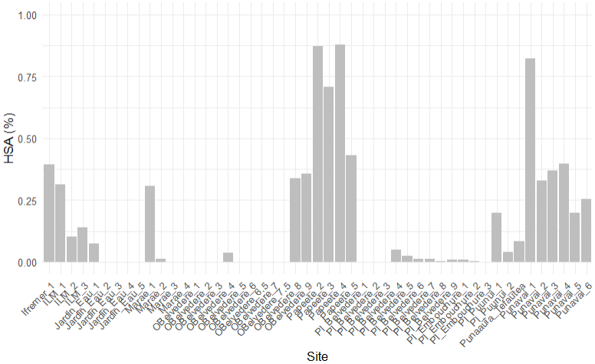

Bird community assessment
Bird point counts of 10 minutes were conducted on two consecutive days for each ARU, usually around 06:00 on the first full day after set tup, and the day after. In total, 101-point count has been realized, with debut. ranging from 05:54 and 06:09 am.
Bird point count can be used to obtain data species occupancies, site richness and community diversity for instance. (Gibb et al., 2019). Here we used precisely, the bird richness (ranging between 3 and 10) and the ratio of native species on exotic (ranging from 0 to 0.5). Without marine species, 13 bird species were captured using ARU, of which ten are exotic.
Other Biotic variable
Azimut et orientation par rapport au centre des îles : https://www.vmaths.fr/apps/calculateur-azimut-distance-gps.html
Daily rainfall and temperature data from MeteoFrance : Can affect bird activity due too..

Lever du jour/Coucher du Jour et Longueur de Jour : https://www.sunrise-and-sunset.com/fr/sun/polynesie-francaise/teahupoo/2024/fevrier

Hour : Estimating dial pattern of bird activity through sounds, can aid to comprehend community dial activity shift, behaviour adaptation to anthropogenic and natural disturbances, as well as mechanisms of coexistence within the acoustic niche hypothesis (bib acousitc niche hypothesis, (Iannarilli et al., 2025)
Animal diel activity patterns can aid understanding of (a) how species behaviourally adapt to anthropogenic and natural disturbances, (b) mechanisms of species co-existence through temporal partitioning, and (c) community or ecosystem effects of diel activity shifts. 2. Activity patterns often vary spatially,
Acoustic Data Collection
Continuous sampling methods was used for every acoustic recording unit on Tahiti (n=51). The ARU utilised were Song Meter recorders disposing of 3 or 4 battery placements (ARU ; Song Meter Micro, Wildlife Acoustics, Inc., Concord, MA, USA), for a sampling rate of 32 kHz and a gain of 18 dB.. For every site, one hour or 30 minutes waves files were created. In total approximately 242 days of recording have been captured within Emma’s field work.
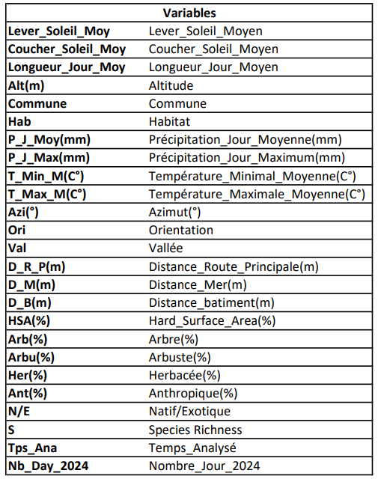
Acoustic Data Analysis
The Data available for this study are acoustic indices (ACI, ADI, AEI, BIO, H and M) and different variables (Tab ?). These variables can be correlated together and it’s the goal to assess potential impact and change of avian invasive species linked to the other variables and acoustic indices.
Fourrier 512 classical
- Comparison of altitude and urban gradient using AID or S(richness) and habitat type for each site
See result
- Barplot of each Habitat type with HSA or fused in only two, with AID
See result
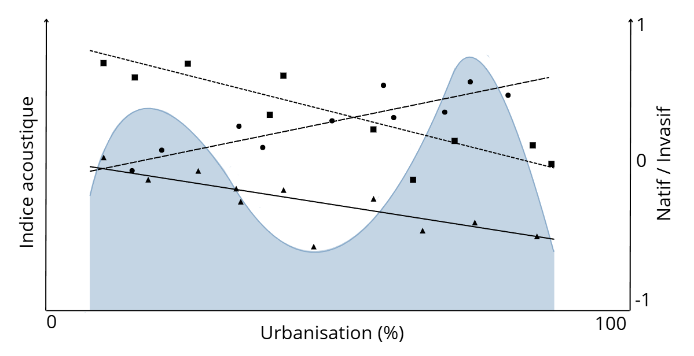
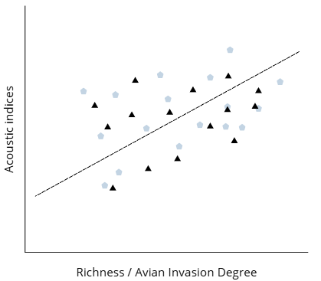
- Graph with means of each acoustic indices (straight line x6) per site with (Alt or HSA) and (S or AID) One acoustic indices with (S or AID) and show direct correlations (pearson).

- Barplot per site or fused by habitat type separated in two, with the six acoustic indices. Could also have a bar plot for each site, still separated within urban or natural habitats

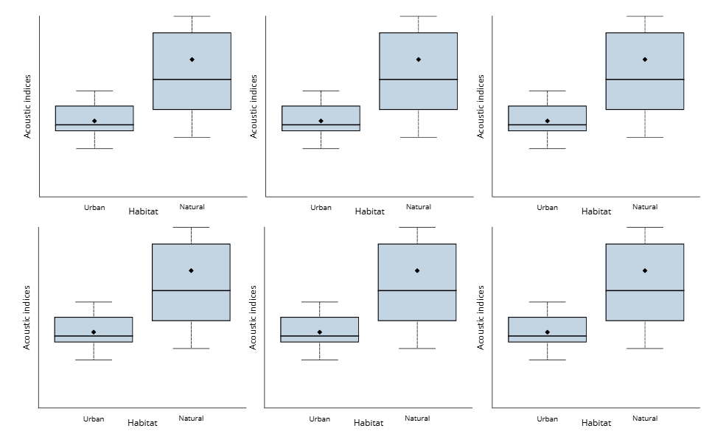

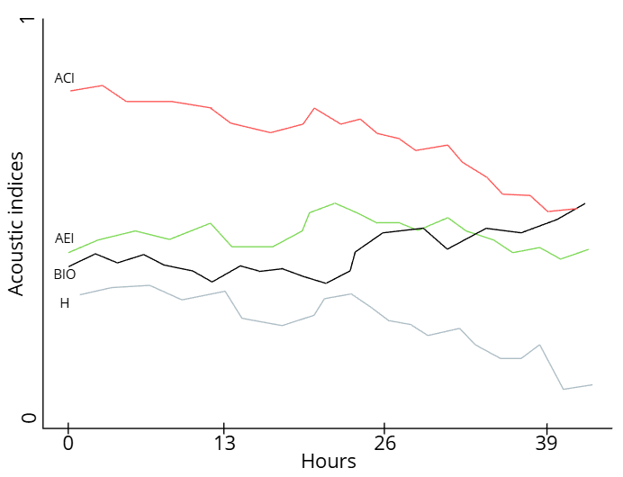
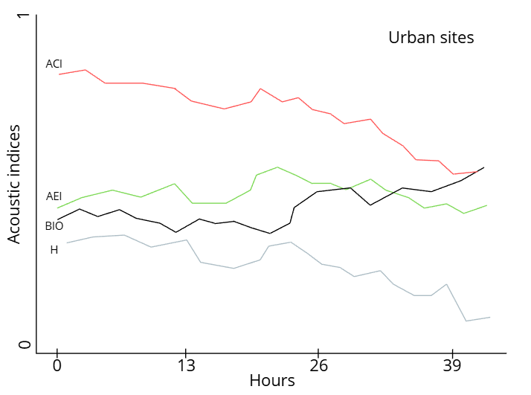
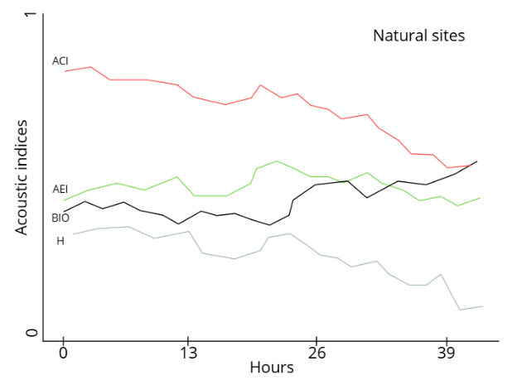
- A graph with each acoustic indices, to look at temporal pattern of each of them first. Then, can look at graph with highly urban and natural sites separated. Needs of standardisation 0-1 and. no straight line, but with standard deviation)

- Can look at the variance of the standard error in our site, to know the minimum hour of recording needed per site.
Acoustic Data Acoustic Indices
- Acoustic data processing to limit analysis length:
We are working on an analysis between 300 and 8000 Hz to take the maximum possible in bird song, without other biotic/anthropogenic disturbance.
For ACI, the means between frequency bins was used for each 5m files analysis, to only have one measure per files.
The files were filtered to uses only days recording, as limited night activity is expected for diurnal bird’s species. So, analysis focus on files recorded and ending between 05:00 h and 19:00 h were kept (source). This filtering of daytime and using only 5 minutes per hour permit to facilitate the analysis and processing effort. Files delimited with 30 minutes wave files, were calculated on one files not two, to be comparable with one-hour waves files. With sufficient recording amount, minimal variability and preciseness is lost compare with full file analysis (Bradfer-Lawrence et al, 2019)
For our first analysis processing, only six different indices (ACI, ADI, AEI, BIO, H, M) are being used to limit data processing.
In our study, when I will have a more precise look at the data, site lasting less than the minimum required for stable variability in indices were excluded, as well as recording which malfunctioned, were corrupted, and so could biased our result.
- Description of Acoustic indices uses.
For better description and tests, use the website to have basic indices described : https://ecohack.shinyapps.io/Acoustic_Index_Users_Guide/ (Bradfer-Lawrence et al., 2025)

For all AI, studies show that in urban environment, for classical AI positively correlated with biophonic sound, are also correlated with anthropogenic noises, showing some bias in urban environments for stronger AI values (Fairbrass et al., 2017).
Saturation pourrait être intéressant à regarder : (Burivalova et al., 2019)
The acoustic complexity index was developed based on the observation that many biotic sounds, such as bird songs, are characterized by an intrinsic variability of intensities, while human-generated noise is often constant in intensity (Pieretti et al., 2011). Pieretti et al. (2011) found that this index correlates with the number of bird vocalizations, while efficiently filtering airplane noise. The acoustic complexity index has been used to describe avian soundscapes (Farina et al., 2011), relate avian soundscapes to vegetation complexity (Farina and Pieretti, 2014) and describe the influence of traffic noise (Pieretti and Farina, 2013). It is calculated as the average absolute fractional change in spectral amplitude, averaged over all frequency bins for the entire recording. (Fuller et al., 2015)
Hyp ACI : Highest value will be in within dominated exotic bird community, as more activity will emerged from this variables places, and also due to anthropic noise.
Similarly, Boelman et al. (2007) developed a bioacoustic index which was a function of both the spectral amplitude and the number of frequency bands in a sound recording. This index was shown to be strongly correlated with avian abundance in Hawaiin forests experiencing weed invasion. (Fuller et al., 2015)
Hyp BIO: More disparity between bands within exotics bird places (amplitude between twio bins, I guess, so higher value. Should be more consistent in less invaded ecosystems
Acoustic diversity indices have also been developed to facilitate automated surveying of ecosystems for rapid biodiversity appraisal (Sueur et al., 2008b, Sueur et al., 2012).
Hyp ADI: Highest value from anthropic noise dominated, and maybe exotic bird dominate (more vocalisation), as their will be more covered in the frequency bands (saturated). Lowest value should come from forest places, where vocalisation is less consistent and more dispartiate but background noise is still present.
The acoustic entropy index is one such index and is computed as the product of both the temporal (acoustic energy dispersal within a recording) and spectral entropies (acoustic energy dispersal through the spectrum) following application of the Shannon index (Sueur et al., 2008b). Simulations revealed a correlation between the acoustic entropy index and species diversity and in field studies this index was found to be sensitive to disturbance in Tanzanian forests (Sueur et al., 2008b).
Hyp: H: Places with even frequency band will give higher value.
. The acoustic diversity index (Villanueva-Rivera et al., 2011) is a modification of spectral entropy and is also calculated using the Shannon index, while the acoustic evenness index uses the Gini coefficient as a measure of evenness (Villanueva-Rivera et al., 2011). (Fuller et al., 2015)
Hyp AEI, saturated places or evenly distributaded places will have lowest value, more intensity difference between two frequency bins will create higher values, maybe exotic bir places will have higher value as less evenly distributed, and forest maybe more consistent.
Hyp M: If it reflect the amplitude, higher amplitude stites, so noisier, should come from exotic bird environments and anthropize sites.

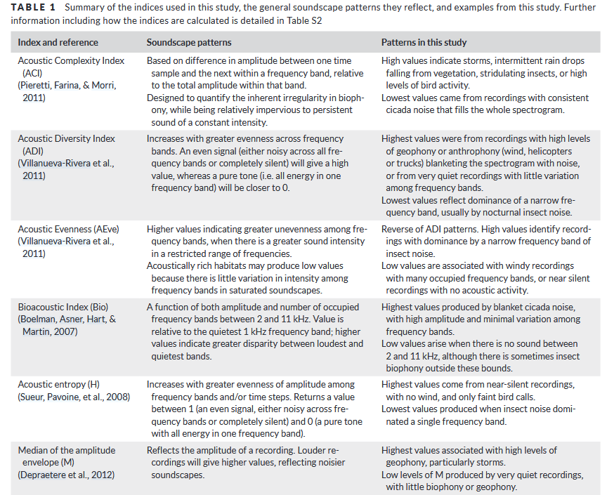
(Bradfer-Lawrence et al, 2019)

Statistical Tests and Models
We use graphical analysis with linear models to looks at global pattern and correlation between biotic and environmental variables
Same goes for acoustic indices using boxplot and graphical curb and linear models to look at temporal pattern and their linked with biotic, environmental variables.
Correlation matrix for explanatory variables used in the generalized linear mixed models. Collinearity between variables was assessed with the VIF function in R, and variables with a VIF score of greater than 5 were removed before the model was run.

  - Results
Data descriptions result

Bioacoustics: Bird Community Composition
Acoustic indices selection
Role of urbanisation gradient (UG) and avian invasive degree (AID)
Show the AID with the UG, or the different habitat type and richness.
For the point count and diversity, uses every Point count done to access, the proportion of each species in the point count and then the proportion of each species for the total number of detection.
- Proportion of terrestrial birds in point count
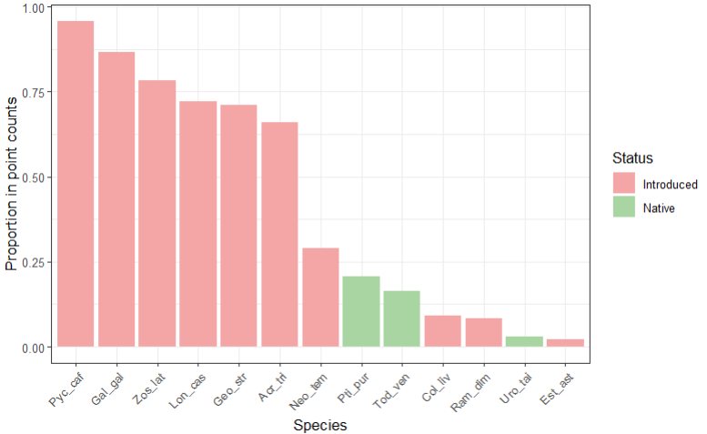
Point count are dominated by exotic species, still about 20% of studied site had some native species detected in one of the two point count realized. 10 exotic birds detected in our site for 3 native one, keeping only nonmarine species.
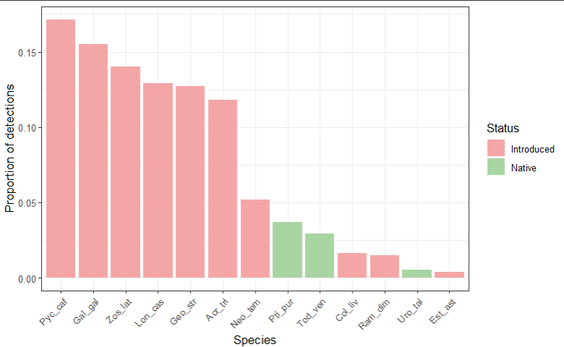
The most detected bird in the 101 point counts made matches with the detected bird in point count.

- Altitudinal and urban gradient
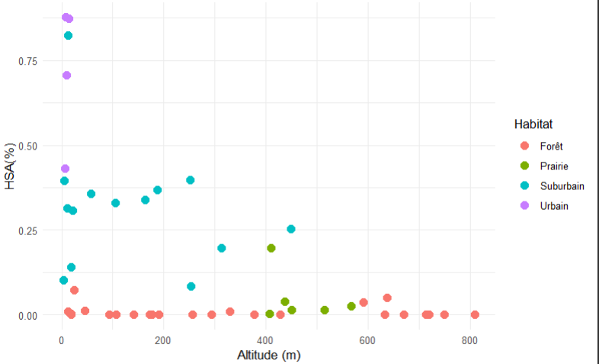
Better distributions of site via Altitudinal gradients, still a bit concentrated in minimal value. HAS value been numerous in less than <25 %. But permit to separate approximately well per Habitat type, whereas habitat x altitude not, marked by forest habitat present on the whole gradient. Disproportionate habitat type selection is marked here with four urban types for 25 forest one. With HSA, Prairie and Forest habitat are well separated from the more urban environment.

- Example of N/E proportion linked to the presence absence of Exotic species (Acr_tri)
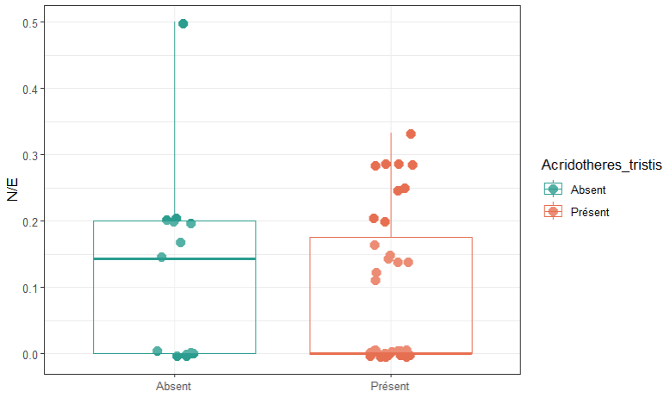
No visual pattern of Native species detection in the presence or absence of Acridotheres tristis, more native species ratio in the presence of the common Myna, but the median value is higher for absence (0.14) than presence (0), that can show for proportionate dataset, more N/E proportion in the absence of this species.

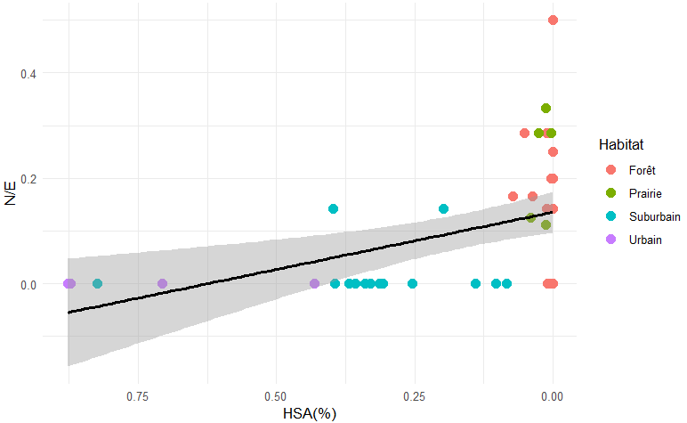
- Comparison of altitude and urban gradient using AID or S(richness) and habitat type for each site.
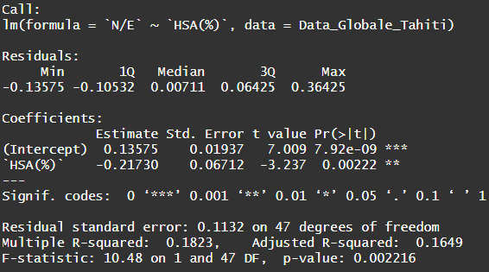

The AID pulls to the 0 for high HSA but still lacking some point to be sure. More site concentrated at 0% HSA, and bigger standard deviation when lacking site at high HAS.
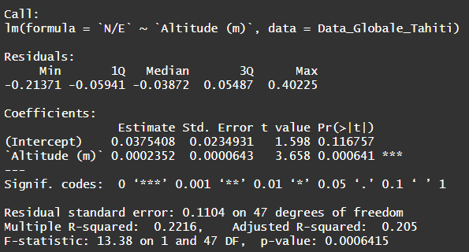
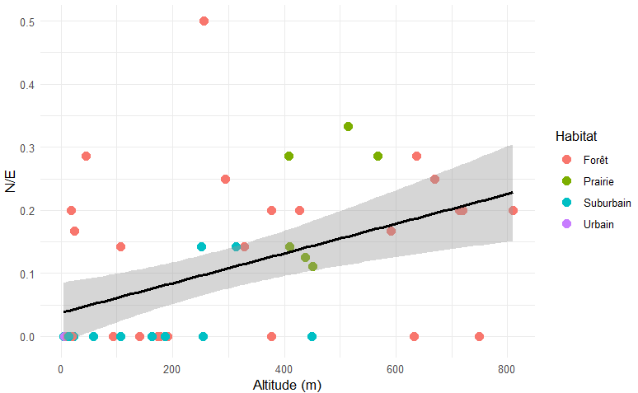

AID is pull to 0 with numerous urban, Suburban and some forest dot with low N/E proportion. Bigger standard deviation at high altitude, less site. In general, the majority of Prairie and forest site still show a relatively good N/E proportion.

The point count method is a big limit to assess the abondance and activity of bird species, working on bird species vocalisation frequencies, or the abondance of frequencies could help with precise assement. Could help with the separation of birdly invaded site and the one less invaded.
Small correlations with the r² between AID and Alt(m) or HAS(%), may so limit the interpretation with analysis using acoustic indices.

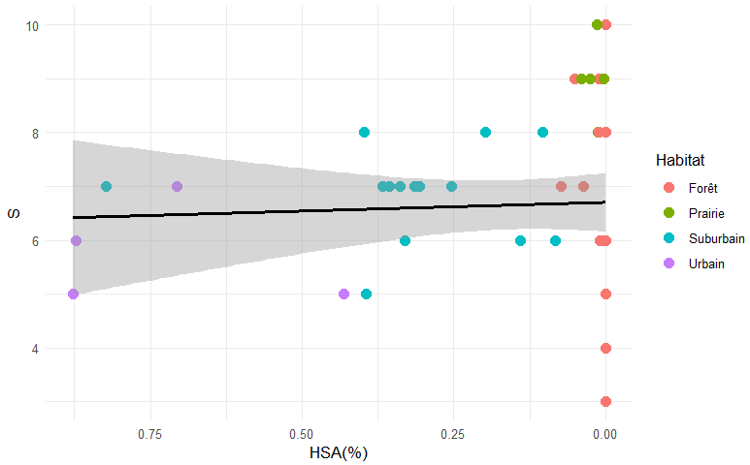
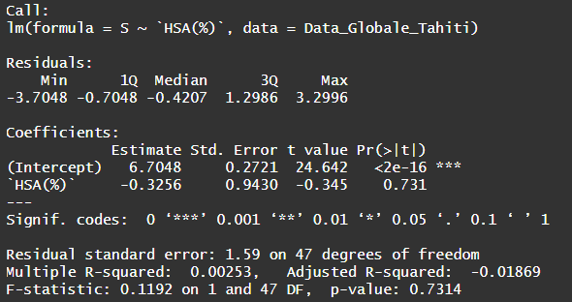

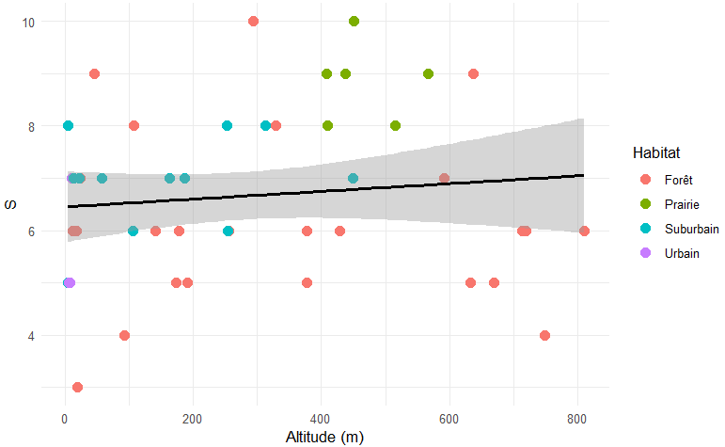
Richness estimation is not affected by urbanisation gradient, sites with low HAS seems to rather have a lot of species (exotic + native) or a lower number of species (native+fewer exotic than high urbanises). Which stabilizes the richness throughout the HAS gradient. Seems to variate a lot between sites. Every rural sites show high diversity, the other habitats are more variable.
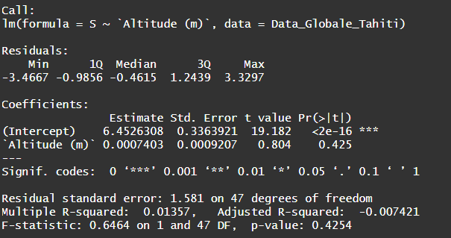

With the altitudinal gradient, sites are more disperdes for their richness. Still, sites at lower altitudes could show an average number of species with only exotic ones, then sites combining exotic and native species between 300 and 600 meter, and low diversty site with onlynatives species and few exotic ones.

Richness is not correlated with altitudes or HAS gradient in our datasets.
The definition of the habitat types could be more precised, as some urban and suburban sites are quite mixed. Using only two habitats type could me more precised.

- Barplot of each Habitat type with HSA or fused in only two, with AID

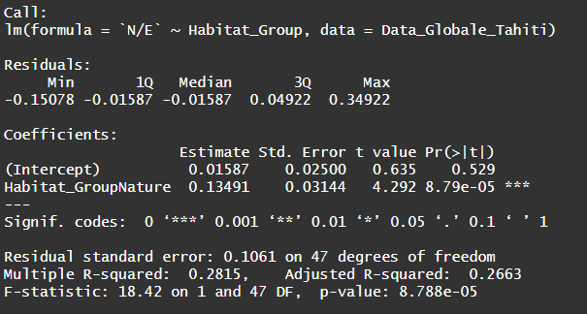
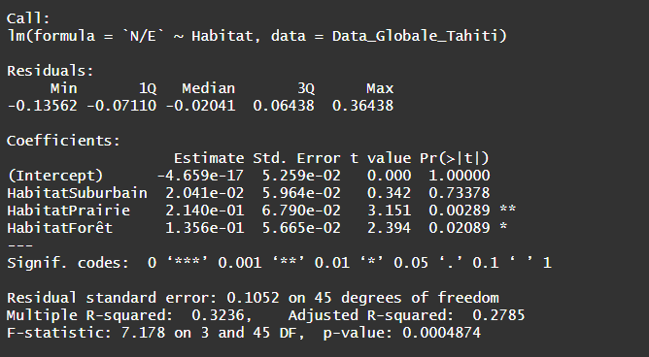
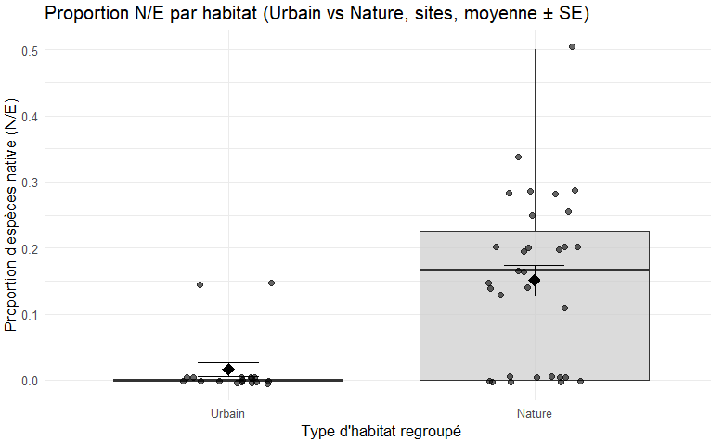
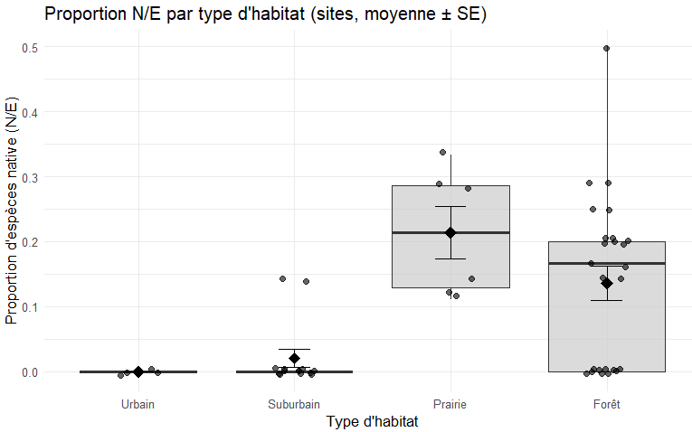
With the linear models, test significantly show two group within the habitat types

Mean and median value are higher and similar for natural habitats types, wheres Urban an Suburban are very restricted in native’s species.
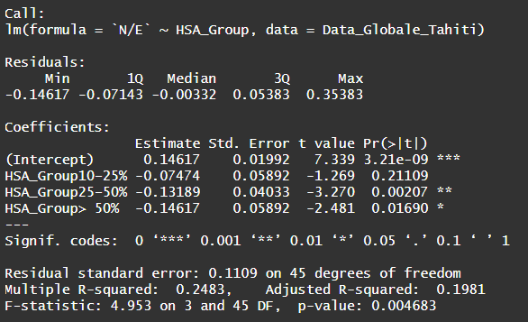
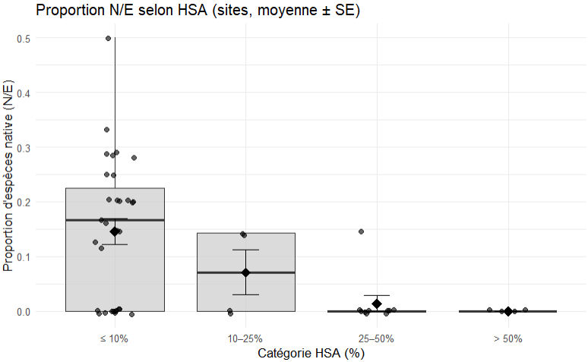
Here the same is described using HAS values, this will permit to explain distinct types of pattern with acoustic indices using HAS on the absicce (x). That could be related to presence or absence of native species

Mean of the acoustic indice for the hour, based on the 5-minute sample
- Means of each acoustic indices (x6) per site with altitudinal and urban gradient, richness and avian invasion degree. Une droite par indices.
- Barplot per site, habitat separated in two, with the mean of each indices. (x6 graph)
- A graph with for each indices, on temporal gradients to look at pattern of each indices, in general and maybe separated with urban and natural sites (milieu type). With standardisation 0-1 and standard deviation. Needs to find a way to have the good files for the good hour for each sites, which differs quite a lot. (x6 graph)

  - Discussion
Compare distribution of sounds between highly invaded and low invaded island, spatially and temporally
With good quantification of frequency of sounds in recorders we could look for pattern in high and low propotion of invasive species.
Pourrait pour certains indices les plus pertinents mettre en avant la corrélation de ces indices avec la richesse ou le AID !!!
Quels différence à utiliser entre un T test classique et un wilcoxon quand on compare le sincides en Bar plot pour un indice type ?.
Limitation : Small number of acoustic indices, classical one.
Duration of recording were also quite short, still the variance in our indices are correct.

Bibliography Traitement des données, on se base sur l’article suivant :
Bradfer-Lawrence T., Gardner N., Bunnefeld L., Bunnefeld N., Willis S.G., et Dent D.H. 2019. Guidelines for the use of acoustic indices in environmental research. Methods in Ecology and Evolution, 10(10), p. 1796-1807. DOI : 10.1111/2041-210X.13254
Choksi P., Kotian M., Biniwale S., Mourya P., Korche D., Agarwala M., Khanwilkar S., Ramesh V., et DeFries R. 2023. Listening for change: quantifying the impact of ecological restoration on soundscapes in a tropical dry forest. Restoration Ecology, 31(4), p. e13864. DOI : 10.1111/rec.13864
Song Z., Yang Z., Xiong Y., et Yang Y. 2025. Assessing the drivers of bird diversity in urban parks during winter: Insights from acoustic indices. Ecological Indicators, 178, p. 113854. DOI : 10.1016/j.ecolind.2025.113854
Rogers A.M., Griffin A.S., Lermite F., van Rensburg B., Archibald C., et Kark S. 2021. The role of invasion and urbanization gradients in shaping avian community composition. Journal of Urban Ecology, 7(1), p. juab030. DOI : 10.1093/jue/juab030
Fairbrass A.J., Rennert P., Williams C., Titheridge H., et Jones K.E. 2017. Biases of acoustic indices measuring biodiversity in urban areas. Ecological Indicators, 83, p. 169-177. DOI : 10.1016/j.ecolind.2017.07.064
Farina A., Pieretti N., et Piccioli L. 2011. The soundscape methodology for long-term bird monitoring: A Mediterranean Europe case-study. Ecological Informatics, 6(6), p. 354-363. DOI : 10.1016/j.ecoinf.2011.07.004
Villanueva-Rivera L.J., Pijanowski B.C., Doucette J., et Pekin B. 2011. A primer of acoustic analysis for landscape ecologists. Landscape Ecology, 26(9), p. 1233-1246. DOI : 10.1007/s10980-011-9636-9
Boelman N.T., Asner G.P., Hart P.J., et Martin R.E. 2007. Multi-Trophic Invasion Resistance in Hawaii: Bioacoustics, Field Surveys, and Airborne Remote Sensing. Ecological Applications, 17(8), p. 2137-2144. DOI : 10.1890/07-0004.1
Sueur J., Pavoine S., Hamerlynck O., et Duvail S. 2008. Rapid Acoustic Survey for Biodiversity Appraisal. PLOS ONE, 3(12), p. e4065. DOI : 10.1371/journal.pone.0004065
Depraetere M., Pavoine S., Jiguet F., Gasc A., Duvail S., et Sueur J. 2012. Monitoring animal diversity using acoustic indices: Implementation in a temperate woodland. Ecological Indicators, 13(1), p. 46-54. DOI : 10.1016/j.ecolind.2011.05.006
Kasten E.P., Gage S.H., Fox J., et Joo W. 2012. The remote environmental assessment laboratory’s acoustic library: An archive for studying soundscape ecology. Ecological Informatics, 12, p. 50-67. DOI : 10.1016/j.ecoinf.2012.08.001
Fuller S., Axel A.C., Tucker D., et Gage S.H. 2015. Connecting soundscape to landscape: Which acoustic index best describes landscape configuration? Ecological Indicators, 58, p. 207-215. DOI : 10.1016/j.ecolind.2015.05.057

